School Counseling MSED
Michele Veasey
mveasey@nwmissouri.edu
The Master of Education School Counseling Program at NW Missouri State is a 45-hour program designed to align with the Missouri Standards for Professional Educators (MOSPE) School Counselor Standards and Quality Indicators, which are aligned with the following national standards: NCTSC Ten Essential Elements for Change in School Counseling Programs, ASCA Standards: School Counselor Competencies, CACREP Standards, NBPTS Counselor Standards. Our curriculum is also aligned with International Society for Technology in Education Standards and Accreditation of Educator Preparation (CAEP/NCATE) standards.
Candidates who participate in the program are generally seeking certification in K-8 or 7-12 School Counseling in the State of Missouri. Some students participate in the program to gain certification in other states. After meeting admission requirements, candidates are required to complete over 300 hours of practicum through three field placement courses, a research component, and a comprehensive assessment in order to be granted the degree. Once candidates have completed the program, they must take a Content Assessment and performance assessment (MEES) Performance Assessment for certification in the State of Missouri. The results of both certification assessments are used to measure program success.
Program Level Outcomes – MS ED School Counseling - Tied to University Outcomes
Communicating - Students who complete the M.S. Ed. School Counseling Program effectively write in APA style and use writing to respond effectively.
Critical Thinking - Students who complete the M.S. Ed. School Counseling Program demonstrate critical thinking about research in education, generate solutions, and evaluate effectiveness.
Diversity, Equity, and Inclusion - Students who complete the M.S. Ed. School Counseling Program demonstrate knowledge of concepts that influence interpersonal interactions in diverse settings and that relate to cultural competence in school counseling.
Managing Information - Students who complete the M.S. Ed. School Counseling Program gather, distill, and present information effectively.
Students are evaluated on these outcomes through multiple course Outcome Assignments. Student performance on these outcomes is considered when making instructional decisions regarding program design and activities.

Incorporating Data:
The chart below shows average scores on the Missouri School Counseling Content Assessment (MoCA) for students who have finished the program and elect to take the assessment as a condition for certification in the State of Missouri. The test consists of 100 multiple choice questions covering three Domains for school counseling.

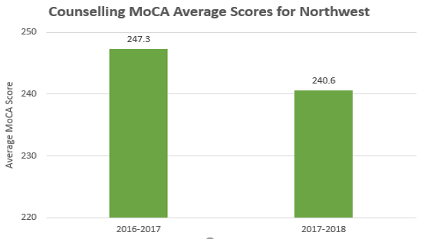
The next chart below shows the average scores in each of the school counseling domains on the content assessment. Instructors in the program review the data and test framework annually in order to make instructional decisions.
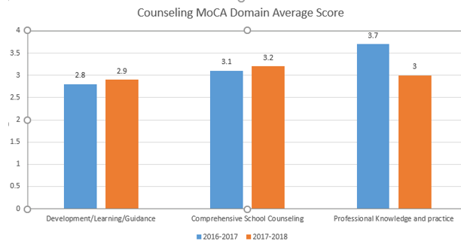
As indicated previously, we collect data on our four program outcomes by using rubrics for our major assessments in each class. Candidates are designated as Met or Unmet on each outcome. Dispositional data is collected on each candidate at three times during the program – first trimester, midpoint, and final trimester. The disposition evaluations are completed by instructors and onsite supervisors. Dispositional data collection started in 2012 and has been used to facilitate students setting personal goals for improvement, assessing student competence, and for evaluating program direction. For example, a collaborative partnership between the Kansas City Youth R.I.S.E. Organization and the NWMSU M.S. Ed. School Counseling Program was developed to offer students in the program experience designing, implementing, and evaluating post-secondary planning activities with diverse populations, as this was consistently indicated as an area with potential for growth reported on the dispositions. The Youth R.I.S.E Workshop is initially developed as a course assignment in 68-650 Career Paths and Exploration and finalized/ implemented as an assignment in 68-640 Group Counseling Techniques.
Partnerships:
Program leaders are heavily involved with major school counseling organizations to stay current and to collaborate regarding practices at the PK-12 Level. Program leaders serve on the Missouri Department of Elementary and Secondary Education (MODESE) Counselor Educator Committee, which is a collaboration of counselor educators from all state approved school counseling programs, Missouri School Counselor Association representatives, and MODESE School Counseling leaders. Our representatives attend regular meetings to develop and make recommendations with regard to policy, standards, certification requirements, and assessments related to school counseling. Program representatives have been involved in planning and designing state school counseling standards and certification assessments through serving on MODESE committees such as the MODESE MEES Performance Assessment Writing Team, MODESE MOSPE Standards Writing and Revision Teams, MODESE School Counselor Growth Guide Writing Team, etc. The partnership with the Kansas City Youth R.I.S.E organization has developed over the past three years (see description of activity in previous section). We plan to continue to develop and grow this relationship to benefit students from both programs. The NWMSU School Counseling Advisory Committee is comprised of school leaders, students in the NWMSU M.S. Ed. School Counseling Program, and program instructors. This committee advises regarding current developments in the PK-12 arena, offers feedback, and makes recommendations for program improvement.

